Know Before You Show

Our mobile app is changing the Real Estate Industry. myMobileLO empowers Real Estate agents to take action & more accurately define EXACTLY how much home their buyers can qualify for.

Pre-Approved "ISH" Syndrome A built-in custom calculator lets you know exactly which homes your client can qualify for. Powered by careful Loan Officer consideration and review of your clients income, you only need to input proposed purchase price, down payment, taxes, HOI, and HOA’s to determine if they are qualified.
Purchase Loan Management Each time a new document is needed, you and your clients will be push notified and emailed with the new status reports. This real time, up to date list creates accountability and transparency. Leading to more timely closings, happy clients and more referrals!

Loan Milestones Checklist Want to know where all of your client’s loans are in the process and what’s next? Check on all of your Buyers Loan progress in seconds!
Instant Pre-Approval Letter If your buyer is qualified based on the accurate housing information on the app, you can have a pre-approval letter emailed to you INSTANTLY. A simple, easy, and quick pre-approval letter at your disposal in a matter of seconds.

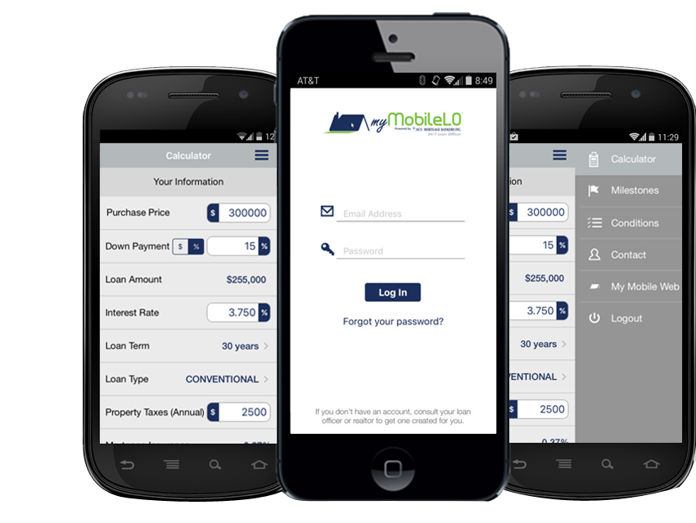

On n R

No more wasted TIME, GAS, OR DISAPOINTED CLIENTS
Insert Contact Info Here:

