Technology on a mission to make buying a home fun, convenient, and stress free.

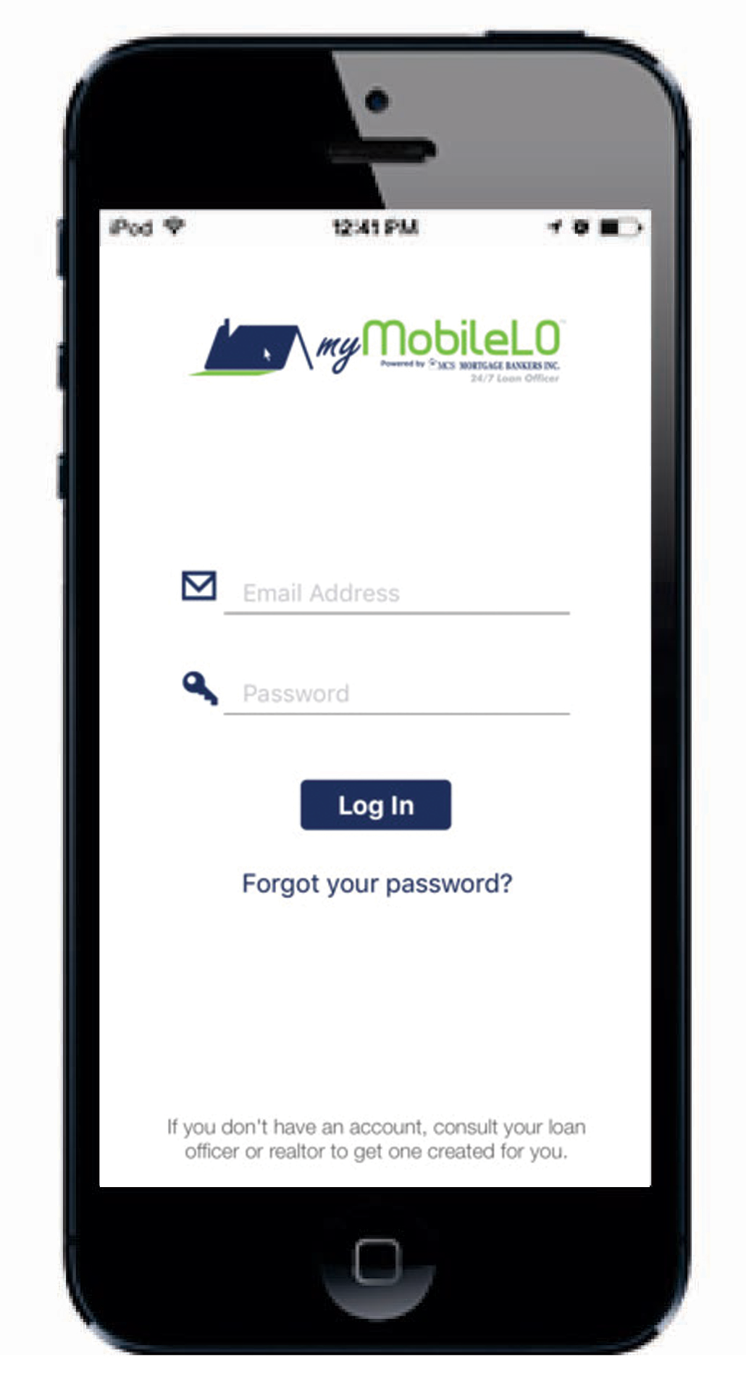
myMobileLO App Login Screen

Getting It Started

This is where realtors and buyers input their username and password, which are provided by the loan officer.

"Know Before You Show"

The myMobileLO App is designed to empower Real Estate
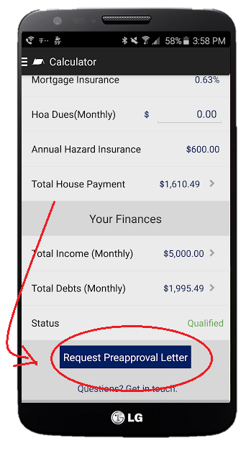
agents to take action & more accurately define EXACTLY how much
home their buyers can qualify for.

No more wasted TIME, GAS, OR DISAPPOINTED CLIENTS

- A built-in custom calculator lets you know exactly which homes your client can qualify for.

- Powered by careful Loan Officer consideration and review of your clients income, you only need to input proposed purchase price, downpayment, taxes, homeowner insurance, and HOA’s to determine if they are qualified.

A Cure For "Pre-Approved ISH Syndrome"

Until now, Loan Officers had to pre-approve YOUR buyers in a “range”, like “You’re pre-approved for $200,000 ISH”.

Print Your Own Pre-Approval Letter
,
If your buyer is qualified based on the accurate housing information on the app, you can have a pre-approval letter emailed to you INSTANTLY.

The “Email Pre-Approval Letter” button is a realtor’s new best friend. A simple, easy, and quick pre-approval letter at your disposal in a matter of seconds. As your preferred lender, I’m always available to take your call and send letters … but no matter how responsive I might be, this is FASTER!!

3 Qualified Statuses

Qualified: Your buyer can afford the proposed home and you have the ability to email an instant pre-approval letter, if your Loan Officer has unlocked the function for that buyer.

Not Qualified: Your buyer can't afford the proposed home and they do not have the ability to get an instant pre-approval letter.

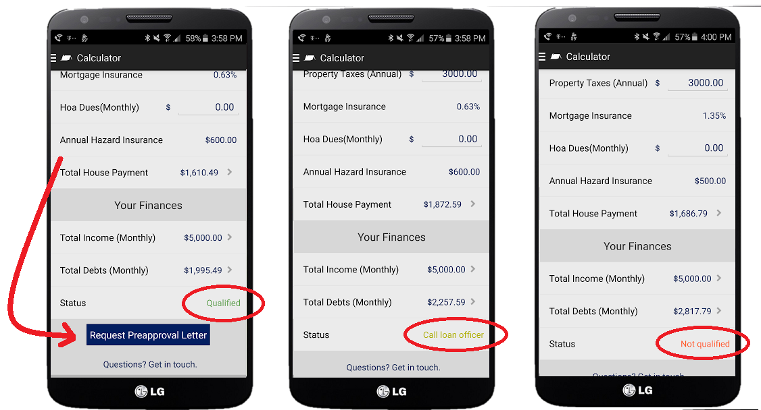
Call Your Loan Officer: Based on the acceptable thresholds established by the Loan Officer, the buyer is on the border line as to whether or not they can afford the home. Your Loan Officer will need to do further investigation to determine if the buyer is qualified. No pre-approval letter button is available.
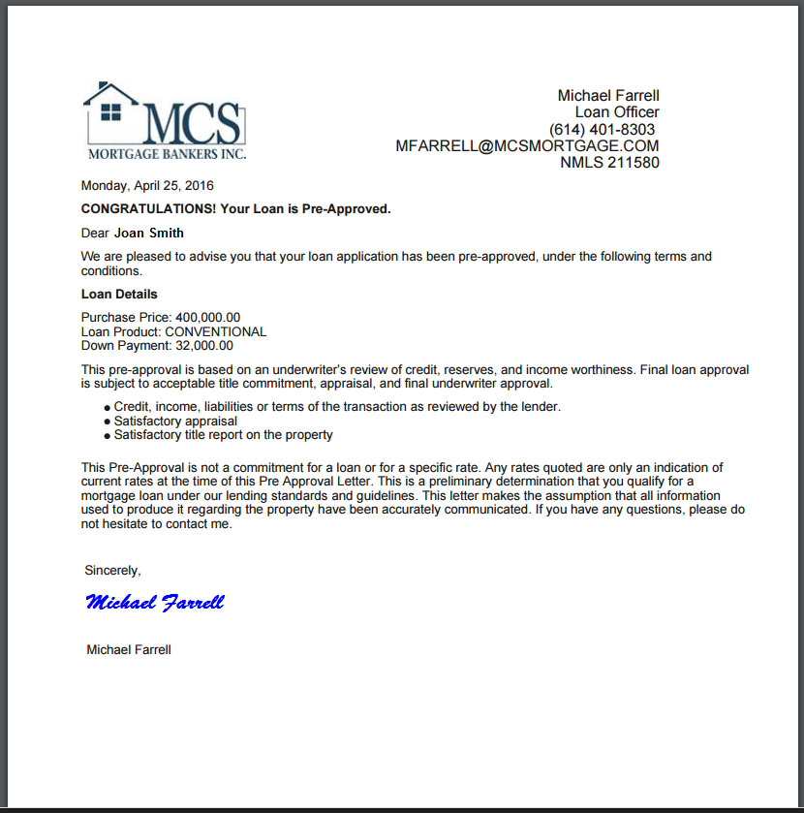
Milestones Tab
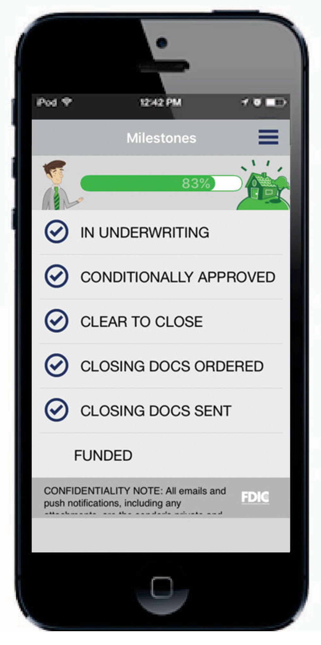
In The Loop At All Times

Providing exceptional service doesn’t stop after an offer has been accepted. The loan process can seem tedious and lengthy so the best way to break it all down is to create a set of milestones a buyer will go through.

After each milestone is reached, a push notification and email status report is sent letting everyone know about the loan process. This keeps everyone in the loop at all times. This is very beneficial to Realtors because buyers spend the majority of their time with you and build the most trust and rapport. So being on top of your game and knowing where the buyer is in the loan process shows you go the extra mile and care about the entire process. This leads to more referrals and business.

Social Sharing Function

Build A Social Presence

Now more than ever in Real Estate is having a presence on social media important to spreading awareness and building up your brand. The social sharing function is a unique tool that spreads the word of your great service and builds your brand on social media.

Along the way when a buyer reaches certain milestones, a pop up appears and asks if they would like to share on Facebook. If the buyer chooses to, they have the ability to write a message on their wall. This is where they give a shout out to their amazing realtor to their friends. Social proof and sphere of influence have a direct effect in building a brand, and as a realtor, it’s a great form of free advertising. People share their big moments on Facebook, and there aren’t a lot of bigger moments than buying a home.
Conditions Tab

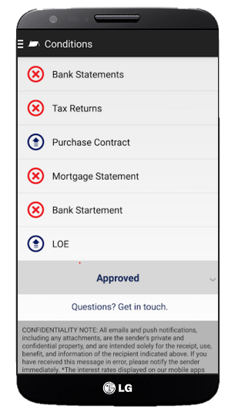
Does it help if you know which loan conditions are needed? That's a trick question. Of course it does.

Perhaps the number one reason why a loan doesn’t close on time is because of a delay in gathering documents. myMobileLO eliminates the confusion and clutter with the conditions tab.

Buyers know exactly which conditions are needed, accepted, declined, and are being reviewed by their Loan Officer.

If a condition is needed, the buyer can take a picture using their phones camera or upload documents from their Dropbox or Google Drive accounts.
A camera icon is shown – then all a buyer needs to do is press the green camera icon and their phones camera is activated. Then the picture is cropped, enhanced, and made perfect.

This process improves the most painful part of the loan process and will help your clients close loans more quickly. Additionally, most buyers jump faster and higher when the Realtor asks. This will make sure you're cued in and ready to say "Jump" if you need to.
Also, push notifications and an email are sent out when new items are needed.

Contacts Tab

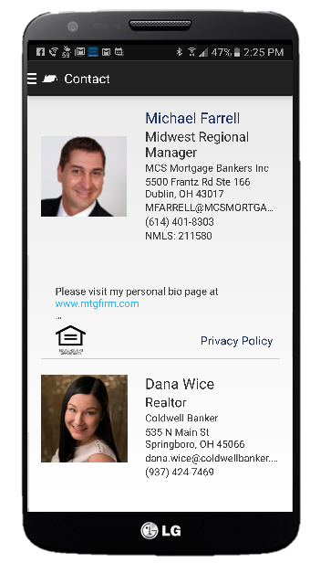
Co-Branded For Easy Access

Buying a home is a TEAM effort. And should be treated as such. The idea behind myMobileLO App is to provide timely up-to-date resources for homebuyers, Realtors and Loan Officers.

It’s a total TEAM effort on all fronts. So when a buyer needs to get in contact with either the realtor or loan officer, all they need to do is click on the contact tab. It’s co-branded with all the contact information from both the realtor and loan officer. myMobileLO App is building a housing revolution. Buying a home is supposed to FUN - Not stressful or overwhelming. This is a very unique tool, and will very soon become the standard in the real estate industry.

Don’t hesitate, or wait and become a technology follower Be at the forefront of your industry and get a piece of technology that is revolutionizing the home buying process.

